Phase 3 – Requirements Document

Intelligent, AI-Powered Circular Campus Resource Exchange and Asset Life Cycle Management System

COSC 336 · Lab Phase 3 · Lab instructor: Eng. Dina Atia
Team member | ID
Nasser Ali Alameri | 100066125
Mohammed Saif Alkuwiti | 100066351
Abdulla Ahmed Alneyadi | 100066085
Abdulrahman Ali Alaryani | 100067036

1. Introduction

1.1 Purpose
This document specifies what the Circular Campus system must do, version 1.0, for the COSC 336 prototype. It turns the Phase 1 findings and the Phase 2 feasibility decision (GO, with scope control) into numbered, testable requirements, use cases and a use-case diagram. It says what the system must do, not how it will be built; architecture and design follow in Phases 4–5.

1.2 Product Scope
The system is an internal web application where Khalifa University departments register assets, publish surplus items, request resources, approve and record transfers, and track each asset through maintenance and end of life. Five AI features support users: asset classification, semantic matching and ranking, sustainable-action recommendations, an LLM assistant, and generated reports. AI output is always advice; an authorised person makes every important decision. Public access, live links to existing university systems and demand forecasting are out of scope for this release.

1.3 Document Conventions
- IDs. Functional requirements are FR-<feature>-<n> (e.g. FR-REQ-3). Non-functional requirements are NFR-<n>, business rules BR-<n>, use cases UC-<n>.
- Wording. "Shall" marks a mandatory requirement. Requirements follow the EARS patterns from the lecture (ubiquitous, "When…", "While…", "If… then…").
- Priority. Every requirement has its own MoSCoW priority: M = Must (essential prototype function), S = Should (desirable extension), C = Could (future enhancement if time allows). Priorities are not inherited.
- TBD. Values still to be agreed with stakeholders are marked [TBD] and listed in Section 8.

1.4 Intended Audience
The lab instructor reviews the full document. Developers should read Sections 2–5; testers should use the numbered requirements and the use-case flows to write Phase 7 test cases. Stakeholders (department representatives, custodians) can read Sections 2 and 6 to confirm the workflows.

1.5 References
- COSC 336 Project Description, Fall 2026 (incl. SRS appendix, Sections 4 and 5.1–5.4)
- Lab Phase 1: Initial Plan and Requirements Gathering Document (13 Sep 2026)
- Lab Phase 2: Feasibility Study
- COSC 336 Lecture 4: Requirements Engineering; Phase 3 lab slides
- ISO/IEC/IEEE 29148:2018; ISO/IEC 25010:2023; WCAG 2.2

2. Overall Description

2.1 Product Perspective
The system is a new, self-contained product. It replaces separate departmental equipment lists with one shared record. The prototype uses React + Vite, FastAPI and PostgreSQL (confirmed in Phase 2), with the five AI features behind one AI service layer that calls the Gemini API. The core workflow must keep working when the AI service is down.

2.2 Actors and User Classes
Actor | Type | Main goals in the system
Requester | Primary (human) | Search and reserve assets, submit requests, track status, use the assistant
Department Representative | Primary (human) | Register and publish department assets, approve or reject requests, record transfers
Asset Custodian | Primary (human) | Keep asset records accurate, confirm handover and receipt, report defects
Maintenance Staff | Primary (human) | Record inspections, repairs and costs; update condition
Sustainability Officer | Primary (human) | Review life-cycle recommendations; approve donation, recycling and disposal; view impact dashboard
Procurement / Finance Officer | Secondary (human) | See reuse matches before a purchase; view savings and asset-value reports
System Administrator | Primary (human) | Manage users, roles, departments, categories and AI settings
AI Service (Gemini API) | Secondary (external system) | Return classifications, embeddings, recommendations, assistant replies and report text
Notification Service (email) | Secondary (external system) | Deliver email copies of system notifications
Generalisation: every human actor is a specialisation of Campus User, so all of them inherit Log In, Search Assets and Use AI Assistant.

2.3 Permissions
This refines the Phase 1 permission table. "Own dept" means only assets or requests belonging to the user's department.
Function | Admin | Dept Rep | Custodian | Requester | Maint. | Sust. Officer
Manage users and roles | Yes | No | No | No | No | No
Register / edit assets | Yes | Own dept | Own assets (if granted) | No | No | No
Publish surplus | Yes | Own dept | Own assets (if granted) | No | No | No
Search and view listings | Yes | Yes | Yes | Yes | Yes | Yes
Submit request / reservation | Yes | Yes | Yes | Yes | No | No
Approve transfer request | Yes | Owning dept | No | No | No | No
Record transfer / confirm receipt | Yes | Own dept | Own assets | No | No | No
Record maintenance | Yes | No | Report only | No | Yes | No
Approve donation / recycling / disposal | Yes | Recommend only | No | No | No | Yes
View reports and dashboard | Yes | Own dept | Own assets | No | Maint. reports | Yes
View audit log | Yes | No | No | No | No | No

2.4 Life-Cycle States
Asset states
State | Meaning | Allowed next states
Registered | Recorded, not yet in use or listed | In Use, Available
In Use | Allocated to a department | Available, Under Maintenance, Pending Disposition
Available | Published as surplus in the marketplace | Reserved, In Use, Under Maintenance, Pending Disposition
Reserved | Held for one request | In Transfer, Available
In Transfer | Approved and being moved | In Use
Under Maintenance | Inspection or repair open | In Use, Available, Pending Disposition
Pending Disposition | Donation, recycling or disposal proposed | Donated, Recycled, Disposed, In Use
Donated / Recycled / Disposed | Final states; record kept read-only | —
Request states: Draft → Submitted → Under Review → Approved or Rejected; Approved → Fulfilled; Submitted or Under Review → Cancelled (by requester) or Expired.
Transfer states: Scheduled → Dispatched → Received (confirmed by receiving custodian) → Completed; Scheduled or Dispatched → Cancelled; Dispatched → Disputed (damage or loss reported on arrival).
Maintenance states: Reported → Inspected → In Repair → Resolved; Inspected → Not Repairable (triggers a sustainability recommendation).

2.5 Operating Environment
Desktop and mobile web browsers (current Chrome, Edge, Safari, Firefox) on the university network or approved VPN. Server: FastAPI on a local or low-cost host, PostgreSQL 15 or later.

2.6 Assumptions and Dependencies
- Representative sample data (departments, assets, requests) is acceptable for development and the demo.
- Each asset has one owning department and one responsible custodian.
- Gemini API access and a test key are available; if not, the matching engine falls back to rule-based search (FR-AI-9).
- Carbon and waste factors for sustainability figures come from a published factor table agreed with the instructor [TBD-1].

3. External Interface Requirements

3.1 User Interfaces
A responsive web interface with a role-based dashboard, top navigation (Assets, Marketplace, Requests, Approvals, Maintenance, Reports, Assistant) and a help link on every screen. Error messages appear next to the field in red text with a plain explanation. AI suggestions are always shown with a confidence value, a reason and Accept / Edit / Dismiss buttons.

3.2 Hardware Interfaces
No special hardware. Users need a computer or phone with a browser; photos may come from a phone or laptop camera upload.

3.3 Software Interfaces
- PostgreSQL 15+ database for all records (assets, users, requests, transfers, history).
- Gemini API (classification, embeddings for matching, recommendations, assistant, report text), called only by the FastAPI backend.
- Email (SMTP) service for notification copies.

3.4 Communications Interfaces
HTTPS (TLS 1.2+) between browser and server; JSON over a REST API between the React front end and FastAPI; HTTPS to the Gemini API with the key kept on the server.

4. System Features
The system has 14 features with 82 functional requirements in total. Each feature gives its description and priority, its stimulus/response sequences and its numbered functional requirements.

4.1 User Accounts and Access Control

4.1.1 Description and Priority
Users log in and act only within their role. Priority: High.

4.1.2 Stimulus/Response Sequences
- User enters email and password → system opens the dashboard for that role.
- User enters a wrong password 5 times → system locks the account for 15 minutes.
- Administrator creates a user → system saves the account and roles.

4.1.3 Functional Requirements
ID | Requirement | Priority
FR-ACC-1 | The system shall let an administrator create, edit and deactivate user accounts with a name, university email, department and one or more roles. | M
FR-ACC-2 | The system shall authenticate users with university email and password before any other function is available. | M
FR-ACC-3 | The system shall check the user's role and department on every request and block actions outside the permission table (Section 2.3). | M
FR-ACC-4 | If a user enters a wrong password 5 times in a row, then the system shall lock the account for 15 minutes. | S
FR-ACC-5 | The system shall let an administrator manage departments, locations and asset categories. | M
FR-ACC-6 | When a session is idle for 30 minutes, the system shall log the user out. | S

4.2 Asset Registration and Inventory

4.2.1 Description and Priority
Authorised users record each asset with its details, photos and documents. Priority: High.

4.2.2 Stimulus/Response Sequences
- User fills the asset form → system shows an AI-suggested category and tags.
- User accepts or edits and saves → system stores the asset with a unique ID.
- User leaves a required field empty → system highlights it and does not save.

4.2.3 Functional Requirements
ID | Requirement | Priority
FR-AST-1 | The system shall record an asset's name, description, category, quantity, owning department, custodian, location, purchase date, estimated value (AED), condition (New, Good, Fair, Poor, Not working) and status. | M
FR-AST-2 | The system shall assign each new asset a unique asset ID. | M
FR-AST-3 | The system shall let the user attach up to 5 photos (JPG/PNG, max 5 MB each) and up to 5 documents (PDF, max 10 MB each). | S
FR-AST-4 | If a required field is missing or invalid, then the system shall not save the asset and shall highlight the field with an error message. | M
FR-AST-5 | The system shall let authorised users edit asset details and shall keep the previous values in the asset history. | M
FR-AST-6 | The system shall only change an asset's status along the transitions in Section 2.4 and shall reject any other change. | M

4.3 Resource Publication (Marketplace)

4.3.1 Description and Priority
Departments list surplus or under-used assets so others can find them. Priority: High.

4.3.2 Stimulus/Response Sequences
- User clicks "Publish as Surplus" → system sets the asset to Available and shows it in the marketplace.
- User clicks "Withdraw" → system removes the listing if it has no approved request.

4.3.3 Functional Requirements
ID | Requirement | Priority
FR-PUB-1 | The system shall let a department representative or authorised custodian publish an asset as Available, with an availability note and optional end date. | M
FR-PUB-2 | When an asset is published, the system shall show it in the marketplace to all logged-in users. | M
FR-PUB-3 | The system shall let the publisher withdraw a listing while it has no approved request. | M
FR-PUB-4 | When a listing reaches its end date with no request, the system shall notify the publisher and ask to extend, withdraw or propose a disposition. | C

4.4 Search and Filtering

4.4.1 Description and Priority
Users find assets by keyword and filters before buying new ones. Priority: High.

4.4.2 Stimulus/Response Sequences
- User types a keyword and picks filters → system lists matching assets.
- No asset matches → system shows "No matching assets" and offers to submit a request.

4.4.3 Functional Requirements
ID | Requirement | Priority
FR-SRC-1 | The system shall search assets by keyword in name, description and tags. | M
FR-SRC-2 | The system shall filter results by category, condition, department, location, quantity, availability, asset age, estimated value and life-cycle status. | M
FR-SRC-3 | The system shall sort results by relevance, newest listing, condition or distance from the requester's location. | S
FR-SRC-4 | When no result is found, the system shall show a "No matching assets" message and offer to submit a resource request. | M
FR-SRC-5 | The system shall show only fields the user's role may see (estimated value is hidden from Requesters). | M

4.5 Resource Requests and Reservations

4.5.1 Description and Priority
Users ask for a specific asset or describe a need for the system to match. Priority: High.

4.5.2 Stimulus/Response Sequences
- Requester clicks "Request" on a listing → system saves the request, reserves the asset and notifies the owning department.
- Requester clicks "Cancel" before approval → system cancels the request and releases the asset.
- Reservation passes 3 working days → system expires it.

4.5.3 Functional Requirements
ID | Requirement | Priority
FR-REQ-1 | The system shall let a user submit a request with category, purpose, specifications, quantity, preferred condition, urgency (Low, Medium, High), delivery location and required date. | M
FR-REQ-2 | The system shall let a user request a specific listed asset, which reserves it for 3 working days pending approval. | M
FR-REQ-3 | If the listed asset is already reserved, then the system shall add the request to a queue in order of submission time. | S
FR-REQ-4 | The system shall let the requester view the current state (Section 2.4) and history of each of their requests. | M
FR-REQ-5 | The system shall let the requester cancel a request before it is approved, releasing any reservation. | M
FR-REQ-6 | When a reservation passes 3 working days without a decision, the system shall expire it and release the asset. | S

4.6 Approval Workflow

4.6.1 Description and Priority
Every transfer and end-of-life action needs a named approver. Priority: High.

4.6.2 Stimulus/Response Sequences
- Representative clicks "Approve" → system sets the request Approved and schedules a transfer.
- Representative clicks "Reject" with a reason → system notifies the requester and suggests alternatives.

4.6.3 Functional Requirements
ID | Requirement | Priority
FR-APR-1 | The system shall send each request to the department representative of the owning department for approval. | M
FR-APR-2 | The system shall let the approver approve or reject a request; a rejection shall require a reason. | M
FR-APR-3 | If a request is rejected, then the system shall notify the requester with the reason and show up to 3 alternative available assets. | S
FR-APR-4 | The system shall not allow a transfer to be recorded for a request that is not Approved. | M
FR-APR-5 | The system shall route donation, recycling and disposal proposals to a sustainability officer for approval. | M
FR-APR-6 | Where the asset value is above a set limit (default AED 20,000 [TBD-2]), the system shall also require administrator approval. | C

4.7 Transfer Management

4.7.1 Description and Priority
Records the physical move and the change of owner, custodian and location. Priority: High.

4.7.2 Stimulus/Response Sequences
- Sender clicks "Mark Dispatched" → system sets the asset In Transfer and notifies the receiver.
- Receiver confirms receipt → system updates owner, custodian, location and status.
- Receiver reports damage → system marks the transfer Disputed.

4.7.3 Functional Requirements
ID | Requirement | Priority
FR-TRF-1 | When a request is approved, the system shall create a transfer record in Scheduled state with collection or delivery method and date. | M
FR-TRF-2 | The system shall let the sending side mark the transfer Dispatched. | M
FR-TRF-3 | The system shall let the receiving custodian confirm receipt and the asset's condition on arrival. | M
FR-TRF-4 | When receipt is confirmed, the system shall update the asset's owning department, custodian, location and status to In Use. | M
FR-TRF-5 | The system shall let users attach handover documents (PDF/image) to a transfer. | S
FR-TRF-6 | If the receiver reports the asset damaged or missing, then the system shall mark the transfer Disputed and notify both departments. | S

4.8 Maintenance and Repair

4.8.1 Description and Priority
Defects, inspections and repairs are logged against the asset. Priority: Medium.

4.8.2 Stimulus/Response Sequences
- Custodian reports a defect → system sets the asset Under Maintenance and notifies maintenance staff.
- Maintenance staff mark the job Resolved → system updates the condition and returns the asset to service.

4.8.3 Functional Requirements
ID | Requirement | Priority
FR-MNT-1 | The system shall let a custodian or any user holding the asset report a defect with a description and optional photo. | M
FR-MNT-2 | When a defect is reported, the system shall set the asset to Under Maintenance and notify maintenance staff. | M
FR-MNT-3 | The system shall let maintenance staff record inspection results, repair actions, parts used, cost (AED) and dates. | M
FR-MNT-4 | When a repair is resolved, the system shall require an updated condition and return the asset to its previous status. | M
FR-MNT-5 | If an asset is marked Not Repairable, then the system shall request a sustainable-action recommendation (FR-AI-10). | S

4.9 End-of-Life Actions

4.9.1 Description and Priority
Donation, recycling, disassembly and disposal are recorded with approval. Priority: Medium.

4.9.2 Stimulus/Response Sequences
- Representative proposes an end-of-life action → system sets Pending Disposition and asks the sustainability officer.
- Officer approves and completion is recorded → system sets the final state.

4.9.3 Functional Requirements
ID | Requirement | Priority
FR-EOL-1 | The system shall let a department representative propose donation, disassembly for parts, recycling or disposal of an asset with a reason. | M
FR-EOL-2 | The system shall set the asset to Pending Disposition until a sustainability officer approves or rejects the proposal. | M
FR-EOL-3 | When the proposal is approved and completed, the system shall record the recipient or vendor, date and certificate (if any) and set the final state. | M
FR-EOL-4 | The system shall keep final-state assets read-only and visible in history and reports. | M

4.10 Life-Cycle History and Audit

4.10.1 Description and Priority
Every important event is kept so an asset's full story can be followed. Priority: High.

4.10.2 Stimulus/Response Sequences
- Any recorded action → system adds a history and audit entry.
- User opens an asset's History tab → system shows the timeline.
- Administrator searches the audit log → system lists matching entries.

4.10.3 Functional Requirements
ID | Requirement | Priority
FR-AUD-1 | The system shall record every life-cycle event (registration, allocation, edit, reservation, transfer, inspection, repair, refurbishment, donation, recycling, disposal) with date/time, user and old/new values. | M
FR-AUD-2 | The system shall show an asset's history as a timeline, newest first. | M
FR-AUD-3 | The system shall not let any user edit or delete history or audit entries. | M
FR-AUD-4 | The system shall log every AI recommendation with model name and version, input summary, output, confidence and the user's final decision. | M
FR-AUD-5 | The system shall let an administrator search the audit log by user, asset, action and date range. | S

4.11 Notifications

4.11.1 Description and Priority
Users are told when something they are involved in changes. Priority: Medium.

4.11.2 Stimulus/Response Sequences
- A request, approval, transfer or maintenance job changes state → system notifies the affected users in-app and by email.
- A new listing matches an open request → system notifies the requester.

4.11.3 Functional Requirements
ID | Requirement | Priority
FR-NOT-1 | When a request, approval, transfer, maintenance or end-of-life record changes state, the system shall send an in-app notification to the affected users. | M
FR-NOT-2 | The system shall also send an email copy of each notification unless the user has turned email off. | S
FR-NOT-3 | When a new listing has a match score of 0.75 or more for an open request, the system shall notify the requester. | S

4.12 Operational Reports

4.12.1 Description and Priority
Standard reports for managing assets and workflows. Priority: Medium.

4.12.2 Stimulus/Response Sequences
- Administrator picks a report type, department and dates → system builds the report.
- Administrator clicks "Export" → system downloads a PDF or CSV.

4.12.3 Functional Requirements
ID | Requirement | Priority
FR-RPT-1 | The system shall generate reports of available assets, open requests, completed transfers, maintenance history, ownership changes, approvals and asset status, filterable by department and date range. | M
FR-RPT-2 | The system shall export any report to PDF and CSV. | S

4.13 AI-Enhanced Features

4.13.1 Description and Priority
Five AI features advise users: classification, matching, sustainable-action recommendation, the assistant and generated reports. None makes a final decision. Priority: High (required by the project brief), built after the core workflow.

4.13.2 Stimulus/Response Sequences
- User enters an asset name and description → system suggests a category and tags.
- Requester submits a need → system shows the top 5 matches with scores and reasons.
- Asset is marked Not Repairable or proposed for end of life → system recommends an action.
- User types a question → assistant answers within the user's permissions.
- AI Service does not answer within 10 seconds → system falls back to rule-based results.

4.13.3 Functional Requirements
ID | Requirement | Priority
FR-AI-1 | Classification. When a user enters an asset's name and description, the system shall suggest a category, subcategory, up to 8 tags, material type and a standard description. | M
FR-AI-2 | The system shall show each classification suggestion with a confidence value and shall save it only after the user accepts or edits it. | M
FR-AI-3 | The system shall list fields the AI finds missing (e.g. no model number) as prompts to the user. | C
FR-AI-4 | Matching. The system shall compare a request with available assets by meaning, not only exact keywords. | M
FR-AI-5 | Before scoring, the system shall exclude assets that fail hard rules: not Available, quantity too low, or condition below the requested minimum. | M
FR-AI-6 | The system shall give each asset–request pair a compatibility score from 0 to 1 using category, purpose, specifications, quantity, condition, location, urgency, required date, transfer cost and repair cost. | M
FR-AI-7 | The system shall show the top 5 matches ranked by score, each with a plain-language reason naming its 2–3 main factors. | M
FR-AI-8 | The system shall rank matches with equal suitability higher when they give more waste diversion or carbon reduction. | S
FR-AI-9 | If the AI service fails or times out after 10 seconds, then the system shall fall back to rule-based keyword search and tell the user AI ranking is unavailable. | M
FR-AI-10 | Sustainable action. The system shall recommend one of: retain, transfer, repair, refurbish, donate, disassemble for parts, recycle or dispose, with a reason and confidence. | M
FR-AI-11 | The system shall never change an asset's state from an AI recommendation without an authorised user's approval. | M
FR-AI-12 | If a recommendation's confidence is below 0.6, then the system shall label it "Low confidence – review carefully". | S
FR-AI-13 | Assistant. The system shall let users ask questions in English (Arabic: C) to search assets, start a request, check status, view asset history and get policy guidance. | M
FR-AI-14 | The assistant shall only return data and run actions the user is permitted to see or do, using the same permission checks as the normal screens. | M
FR-AI-15 | Before the assistant submits a request on the user's behalf, the system shall show a summary and require the user to confirm. | M
FR-AI-16 | Generative reports. The system shall produce a monthly narrative report on exchanges, maintenance trends, avoided purchases, savings, waste diversion, carbon reduction, high-demand categories and suggested actions. | M
FR-AI-17 | Every number in a generated report shall come from database totals computed by the system; the AI writes only the narrative. | M
FR-AI-18 | The system shall let any user override or dismiss an AI suggestion, and shall record the override (FR-AUD-4). | M

4.14 Sustainability Measurement

4.14.1 Description and Priority
Measures the environmental and financial value of reuse. Priority: Medium.

4.14.2 Stimulus/Response Sequences
- Transfer completes → system asks whether it replaced a planned purchase.
- Sustainability officer opens the dashboard → system shows savings, waste diverted, CO2e and reuse rate by department and month.

4.14.3 Functional Requirements
ID | Requirement | Priority
FR-SUS-1 | When a request is fulfilled by reuse, the system shall ask whether it replaced a planned purchase and record that as an avoided purchase. | M
FR-SUS-2 | The system shall compute financial savings as the estimated replacement cost of avoided purchases minus transfer and repair costs (AED). | M
FR-SUS-3 | The system shall compute waste diverted (kg) from each reused, repaired, donated or recycled asset, using a weight per category. | S
FR-SUS-4 | The system shall estimate carbon reduction (kg CO2e) using an emission factor per category from the agreed factor table [TBD-1], shown as an estimate with its source. | S
FR-SUS-5 | The system shall compute reuse rate (fulfilled-by-reuse requests ÷ all fulfilled requests) and asset-life extension (years added by reuse or repair). | S
FR-SUS-6 | The system shall show these indicators on a dashboard by department and month. | M

5. Other Nonfunctional Requirements
Each quality requirement has a measurable target so it can be tested in Phase 7 (lecture rule: if you can't test it, it isn't a requirement yet). Load targets assume the prototype's expected peak of 100 concurrent users [TBD-3].

5.1 Performance Requirements
ID | Requirement | Priority
NFR-1 | 95% of keyword searches and filter changes shall return results within 2 seconds with 100 concurrent users. | M
NFR-2 | 95% of AI match lists shall be returned within 8 seconds; after 10 seconds the fallback in FR-AI-9 applies. | M
NFR-3 | Saving an asset, request or approval shall complete within 2 seconds for 95% of attempts. | M
NFR-4 | A monthly generated report shall be produced within 60 seconds. | S

5.2 Safety Requirements
ID | Requirement | Priority
NFR-5 | The system shall require a confirmation dialog before any irreversible action (final disposal, recycling, account deactivation). | M
NFR-6 | Assets flagged as hazardous (e.g. batteries, chemicals, lab equipment) shall require a safety-inspection record before transfer, donation or disposal can be approved. | S
NFR-7 | The core workflow (register, search, request, approve, transfer) shall remain usable when the AI service is unavailable. | M

5.3 Security Requirements
ID | Requirement | Priority
NFR-8 | Passwords shall be stored only as salted hashes (bcrypt or Argon2). | M
NFR-9 | All traffic between browser and server shall use HTTPS (TLS 1.2 or later). | M
NFR-10 | 100% of tested unauthorised actions (all roles against restricted functions) shall be blocked, including through the assistant. | M
NFR-11 | API keys for the AI service shall be kept in server-side environment settings, never in source code or the browser. | M
NFR-12 | Only the minimum data needed shall be sent to the AI service; no passwords, personal phone numbers or financial account details. | M
NFR-13 | Audit entries shall be kept for at least 3 years and shall be append-only. | S
NFR-14 | Personal data handling shall follow university policy and the UAE PDPL (Decree-Law 45/2021). | S

5.4 Software Quality Attributes
ID | Attribute | Requirement | Priority
NFR-15 | Usability | At least 80% of first-time test users shall register an asset and submit a request without help, each task in under 5 minutes. | M
NFR-16 | Accessibility | All pages shall meet WCAG 2.2 level AA and be usable by keyboard only. | S
NFR-17 | Availability | The prototype shall be available 99% of the time during the demo and testing weeks (8:00–20:00). | S
NFR-18 | Reliability | No committed transaction shall be lost; the database shall be backed up daily and restorable within 4 hours. | M
NFR-19 | Maintainability | AI features shall sit in a separate service module so the AI provider can be replaced without changing other modules. | M
NFR-20 | Testability | Each Must requirement shall have at least one automated or documented test case linked to its ID. | M
NFR-21 | AI quality | At least 70% of 20 prepared test requests shall have a relevant asset in the top 3 matches. | M
NFR-22 | AI quality | At least 80% of 10 test assets shall receive the correct category from the AI classifier. | M
NFR-23 | AI quality | Generated reports shall contain 0 numbers that differ from the database totals in 5 tested reports. | M
NFR-24 | Explainability | 100% of shown matches and recommendations shall include a reason and a confidence value. | M
NFR-25 | Fairness | Over the test set, top-3 match relevance shall not differ by more than 15 percentage points between requesting departments. | C
NFR-26 | Portability | The UI shall work on screens from 360 px (phone) to 1920 px wide. | S

5.5 Business Rules
ID | Rule
BR-1 | An asset belongs to exactly one department and has exactly one custodian at any time.
BR-2 | No asset may change department without an Approved request and a confirmed receipt.
BR-3 | A user may not approve their own request.
BR-4 | Only the owning department's representative (or an administrator) approves a transfer of that department's asset.
BR-5 | Donation, recycling and disposal require sustainability-officer approval; disposal is the last option after reuse, repair, donation and recycling are ruled out.
BR-6 | AI output is advisory only; the approving user is accountable for the decision.
BR-7 | A reservation holds an asset for at most 3 working days without a decision.
BR-8 | Final-state assets (Donated, Recycled, Disposed) cannot be reactivated.
BR-9 | Before a purchase request is raised, procurement shall check the marketplace for a match (supported by FR-AI-4).

6. Use Cases
The system has 22 use cases, and every one of the 82 functional requirements is covered by at least one of them (full map in 7.4). Section 6.1 lists them; 6.2 gives each use case its own diagram and description; 6.3 combines them all in one diagram.

6.1 Use-Case List
ID | Use case | Primary actor (initiator) | Secondary actors | FRs covered
UC-1 | Log In | Campus User | — | FR-ACC-2, 3, 4, 6
UC-2 | Register Asset | Department Representative / Custodian | AI Service | FR-AST-1, 2, 3, 4, 6
UC-3 | Classify Asset with AI («include» of UC-2) | — | AI Service | FR-AI-1, 2, 3, 18
UC-4 | Publish Surplus Asset | Department Representative / Custodian | — | FR-PUB-1, 2; FR-NOT-3
UC-5 | Search Assets | Campus User | — | FR-SRC-1–5
UC-6 | Submit Resource Request | Requester | Department Representative | FR-REQ-1, 2, 3; FR-NOT-1, 2
UC-7 | Match Assets with AI («include» of UC-6) | — | AI Service | FR-AI-4–9, 18
UC-8 | Review Request | Department Representative | Requester, Notification Service | FR-APR-1, 2, 3, 4, 6; FR-TRF-1
UC-9 | Record Transfer | Department Representative | Asset Custodian | FR-TRF-1–6; FR-SUS-1
UC-10 | Record Maintenance | Maintenance Staff | Asset Custodian | FR-MNT-2, 3, 4, 5
UC-11 | Process End-of-Life Action | Department Representative | Sustainability Officer | FR-EOL-1–4; FR-APR-5
UC-12 | Recommend Sustainable Action («include» of UC-11, «extend» of UC-10) | — | AI Service | FR-AI-10, 11, 12, 18
UC-13 | Ask AI Assistant | Campus User | AI Service | FR-AI-13, 14, 15
UC-14 | Generate Sustainability Report | Sustainability Officer | Procurement/Finance Officer, AI Service | FR-AI-16, 17; FR-SUS-2–6
UC-15 | Manage Users and Roles | System Administrator | — | FR-ACC-1, 5
UC-16 | Edit Asset | Department Representative / Custodian | — | FR-AST-5, 6
UC-17 | Withdraw Listing | Department Representative / Custodian | — | FR-PUB-3, 4
UC-18 | Track or Cancel Request | Requester | — | FR-REQ-4, 5, 6
UC-19 | Report Defect | Asset Custodian | Maintenance Staff | FR-MNT-1, 2
UC-20 | View Asset History | Campus User | — | FR-AUD-1, 2, 3
UC-21 | View Audit Log | System Administrator | — | FR-AUD-3, 4, 5
UC-22 | Generate Operational Report | System Administrator | — | FR-RPT-1, 2

6.2 Use-Case Diagrams and Descriptions

UC-1: Log In
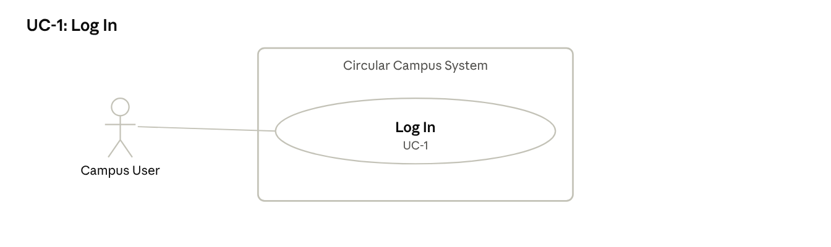
UC-1 use-case diagram
Description: A user proves their identity and gets the screens for their role.
Actors: Campus User (primary).
Preconditions: User has an active account.
Trigger: User opens the system.
Main flow:
- User enters university email and password.
- System verifies the credentials.
- System loads the user's roles and department.
- System opens the dashboard showing only functions allowed for those roles (FR-ACC-3).
Alternative flows: 4a. Session idle for 30 minutes: system logs the user out and returns to step 1 (FR-ACC-6).
Exception flows: 2a. Wrong password: system shows an error. 2b. Fifth wrong attempt in a row: system locks the account for 15 minutes (FR-ACC-4). 2c. Account deactivated: system refuses login and tells the user to contact the administrator.
Postconditions: User session started; login recorded in the audit log.

UC-2: Register Asset
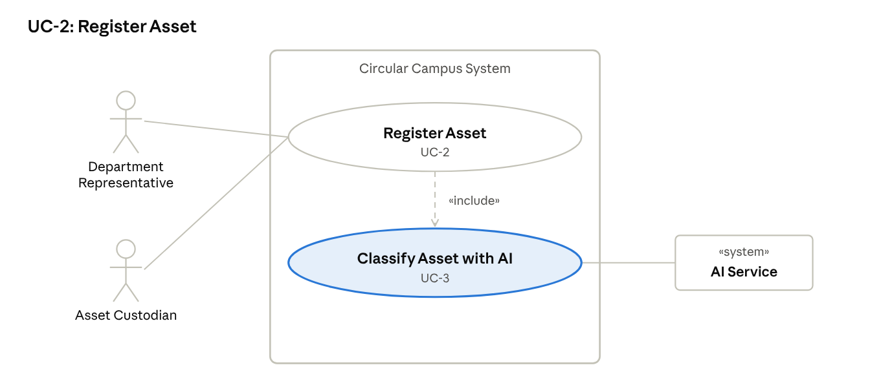
UC-2 use-case diagram
Description: An authorised user records a new asset so it appears in the shared inventory with a standard category.
Actors: Department Representative or Asset Custodian (primary, initiator); AI Service (secondary).
Preconditions: User is logged in (UC-1) and has register permission for the department.
Trigger: User clicks "Add Asset".
Main flow:
- User enters name, description, quantity, location, purchase date, estimated value and condition, and attaches photos.
- System sends the name and description to the AI Service (UC-3).
- System shows the suggested category, tags and standard description with a confidence value.
- User accepts or edits the suggestions.
- System validates all required fields.
- System saves the asset with a unique asset ID and status Registered.
- System records a "Registered" event in the asset history and confirms to the user.
Alternative flows:
- 3a. AI Service unavailable: system shows the normal category list; user picks a category manually; flow continues at step 5.
- 3b. Confidence below 0.6: suggestion is shown with a "Low confidence" label.
Exception flows:
- 5a. Required field missing or invalid (e.g. negative value, file over 5 MB): system highlights the field and does not save.
Postconditions: Asset stored with status Registered; history and audit entries created; AI suggestion and user decision logged.
Rules: BR-1 (one department, one custodian).

UC-3: Classify Asset with AI
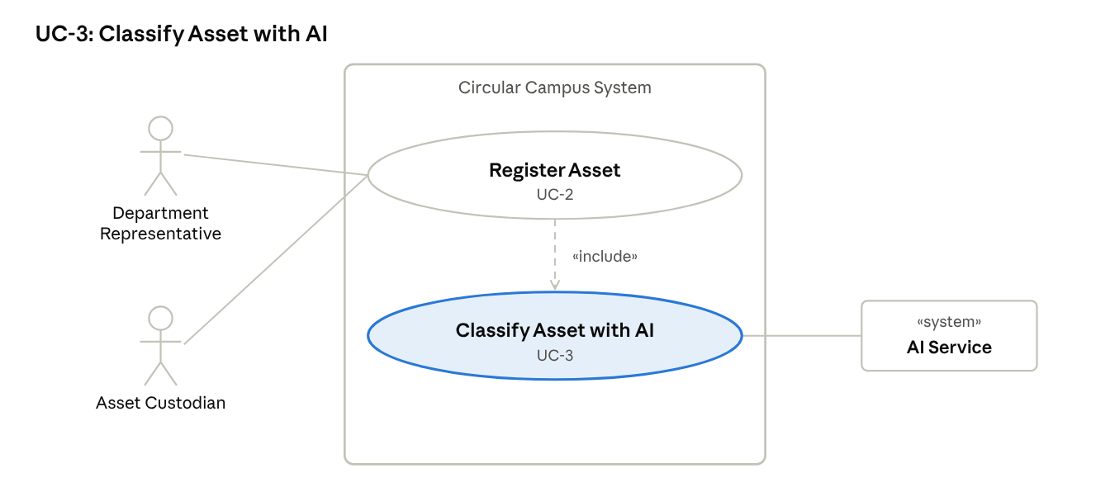
UC-3 use-case diagram
Description: Included in UC-2; the AI suggests how to describe and categorise a new asset.
Actors: AI Service (secondary); started by UC-2.
Preconditions: Name and description entered in UC-2.
Trigger: UC-2 step 2.
Main flow:
- System sends the name, description and specifications to the AI Service.
- AI Service returns category, subcategory, up to 8 tags, material type, standard description and confidence.
- System lists any missing fields as prompts (FR-AI-3).
- System returns the suggestion to UC-2 for the user to accept or edit (FR-AI-2, FR-AI-18).
Alternative flows: 2a. Confidence below 0.6: suggestion marked "Low confidence".
Exception flows: 1a. AI Service unavailable: UC-2 continues with manual category selection.
Postconditions: Suggestion, model version and user decision logged.

UC-4: Publish Surplus Asset
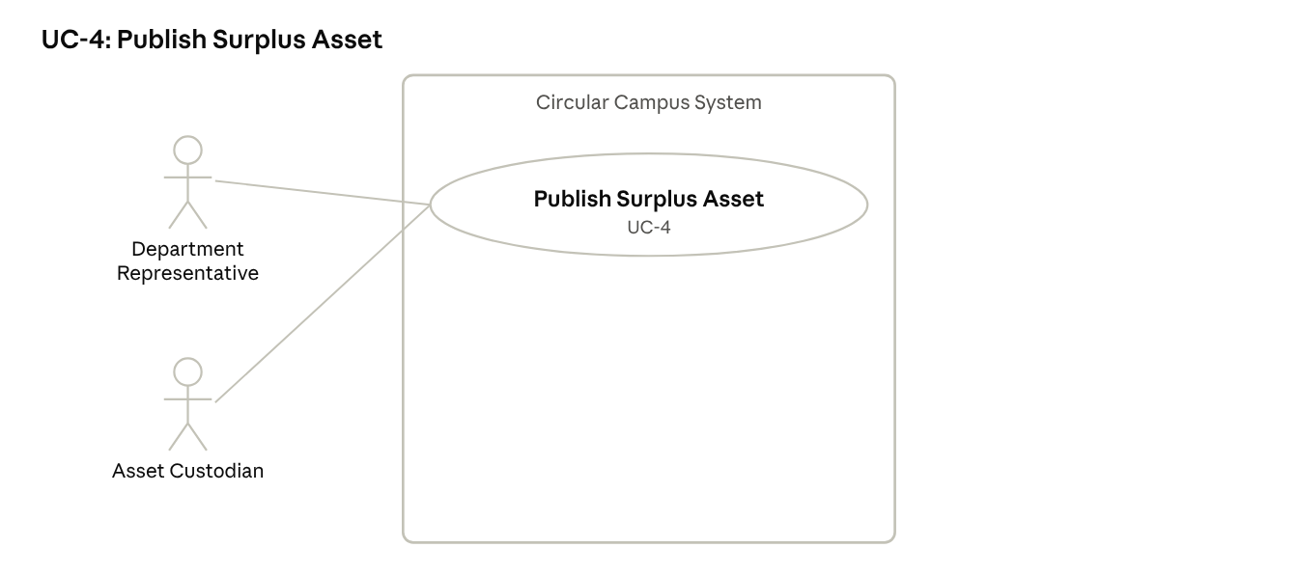
UC-4 use-case diagram
Description: A department makes an unused asset visible in the campus marketplace.
Actors: Department Representative or authorised Custodian (primary).
Preconditions: Asset exists, belongs to the user's department and is Registered, In Use or back from maintenance.
Trigger: User clicks "Publish as Surplus" on the asset page.
Main flow:
- System shows the asset details and asks for an availability note and optional end date.
- User confirms the condition and enters the note.
- System sets the status to Available.
- System adds the listing to the marketplace.
- System checks open requests and notifies requesters with a match score of 0.75 or more (FR-NOT-3).
Alternative flows: 2a. Condition has changed: user updates it before publishing.
Exception flows: 1a. Asset is Under Maintenance or Pending Disposition: system blocks publishing and shows the reason.
Postconditions: Asset is Available and visible to all logged-in users; event logged.

UC-5: Search Assets
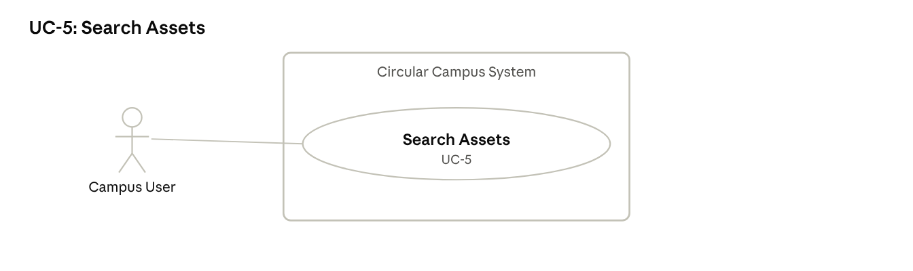
UC-5 use-case diagram
Description: A user finds available assets before buying new ones.
Actors: Any Campus User (primary).
Preconditions: User is logged in.
Trigger: User types a keyword or opens the marketplace.
Main flow:
- User enters a keyword and optional filters (category, condition, department, location, availability, age, value).
- System returns matching assets the user is allowed to see, sorted by relevance.
- User opens an asset to see photos, condition, location and history summary.
- User may continue to UC-6 to request it.
Alternative flows: 2a. User changes the sort order or filters; system refreshes the list.
Exception flows: 2b. No results: system shows "No matching assets" and offers to submit a general request (UC-6).
Postconditions: None stored (search is read-only).

UC-6: Submit Resource Request
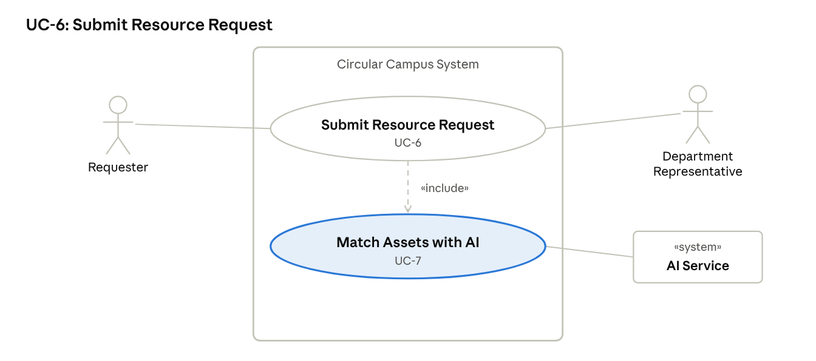
UC-6 use-case diagram
Description: A requester asks for a resource, either a specific listing or a described need that the AI matches.
Actors: Requester (primary, initiator); Department Representative of the owning department (secondary, receives the request); AI Service (secondary, via UC-7).
Preconditions: Requester is logged in and has request permission.
Trigger: Requester clicks "Request" on a listing, or "New Request".
Main flow:
- Requester enters category, purpose, specifications, quantity, preferred condition, urgency, location and required date.
- System filters available assets by hard rules and asks the AI Service to score them (UC-7).
- System shows the top 5 matches with scores and reasons.
- Requester selects one asset.
- System saves the request as Submitted and reserves the asset for 3 working days.
- System notifies the owning department's representative.
- Requester sees the request in "My Requests" with its status.
Alternative flows:
- 1a. Requester started from a listing: the asset is pre-selected; flow goes to step 5.
- 3a. No suitable match: requester saves the request as Open; system notifies them when a matching listing appears.
- 5a. Asset already reserved: request joins the queue for that asset.
Exception flows:
- 2a. AI Service fails or takes over 10 s: system shows rule-based keyword results instead and says AI ranking is unavailable.
- 5b. Required field missing: system highlights it and does not save.
Postconditions: Request stored as Submitted (or Open); asset Reserved; notification sent; AI match list logged.
Rules: BR-7 (3-day reservation limit).

UC-7: Match Assets with AI
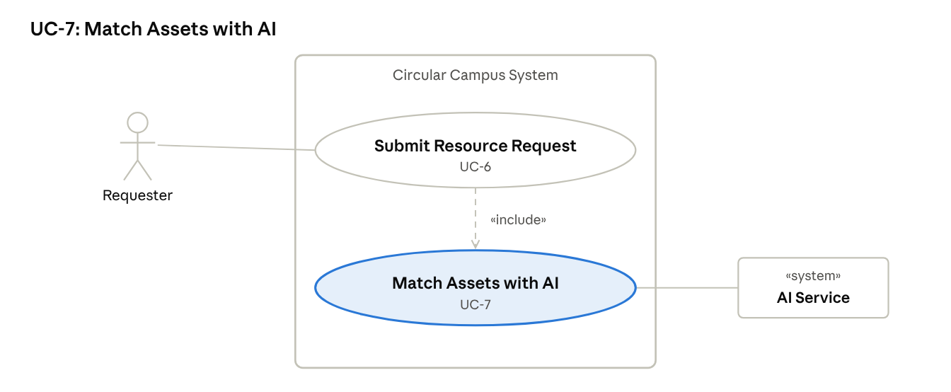
UC-7 use-case diagram
Description: Included in UC-6; ranks available assets against a request.
Actors: AI Service (secondary); started by UC-6.
Preconditions: Request details entered in UC-6.
Trigger: UC-6 step 2.
Main flow:
- System removes assets that fail hard rules (not Available, quantity too low, condition below minimum).
- System sends the request and remaining assets to the AI Service for semantic scoring.
- System combines the score with location, urgency, date, transfer and repair cost into a 0–1 compatibility score.
- System ranks equal-suitability matches higher if they give more waste diversion or carbon reduction.
- System returns the top 5, each with a plain-language reason.
Alternative flows: 1a. No asset passes the hard rules: system returns an empty list and UC-6 continues at 3a.
Exception flows: 2a. AI Service fails or takes over 10 s: rule-based keyword search is used instead (FR-AI-9).
Postconditions: Match list, scores and model version logged; the requester's choice or override recorded (FR-AI-18).

UC-8: Review Request
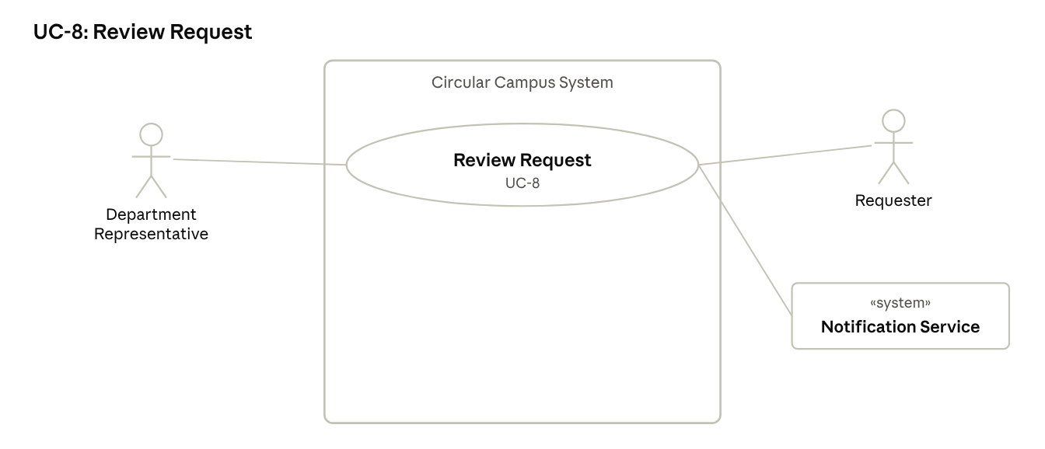
UC-8 use-case diagram
Description: The owning department approves or rejects a request for its asset.
Actors: Department Representative (primary); Requester and Notification Service (secondary).
Preconditions: A Submitted request exists for an asset owned by the representative's department.
Trigger: Representative opens the request from a notification or the approvals list.
Main flow:
- System shows the request, the asset, the AI match score and reason.
- Representative reviews and clicks Approve.
- System sets the request to Approved and creates a Scheduled transfer (UC-9).
- System notifies the requester.
Alternative flows: 2a. Representative rejects with a reason: system sets Rejected, releases the reservation, notifies the requester and suggests up to 3 alternatives.
Exception flows:
- 2b. Representative is also the requester: system blocks the approval (BR-3) and routes it to an administrator.
- 2c. Reservation expired before review: system marks the request Expired and informs both sides. 2d. Asset value above the set limit: system also requires administrator approval (FR-APR-6).
Postconditions: Request is Approved or Rejected; decision, approver and time logged.

UC-9: Record Transfer
↗ UC-9 use-case diagram
Description: The move of an approved asset is recorded until the receiver confirms it.
Actors: Department Representative of sending department (primary); Asset Custodian of receiving department (secondary).
Preconditions: Request is Approved; transfer is Scheduled.
Trigger: Sending side clicks "Mark Dispatched".
Main flow:
- Sender confirms collection or delivery date and attaches a handover form.
- System sets the transfer to Dispatched and the asset to In Transfer, and notifies the receiver.
- Receiving custodian confirms receipt and the condition on arrival.
- System updates the asset's department, custodian, location and status (In Use).
- System sets the request to Fulfilled and asks whether it avoided a purchase (FR-SUS-1).
Alternative flows: 1a. Date changes: sender edits the schedule; receiver is notified.
Exception flows: 3a. Asset damaged or missing on arrival: receiver reports it; transfer becomes Disputed; both departments and the administrator are notified.
Postconditions: Ownership and location updated; transfer Completed; history shows the move.
Rules: BR-2 (no department change without approval and confirmed receipt).

UC-10: Record Maintenance
↗ UC-10 use-case diagram
Description: Maintenance staff log an inspection or repair and update the asset's condition.
Actors: Maintenance Staff (primary); Asset Custodian (secondary, reports the defect).
Preconditions: A defect has been reported on the asset (status Under Maintenance).
Trigger: Maintenance staff open the job from their queue.
Main flow:
- Staff record the inspection result.
- Staff record repair actions, parts, cost (AED) and date.
- Staff mark the job Resolved and set the new condition.
- System returns the asset to its previous status and notifies the custodian.
Alternative flows: 1a. No fault found: staff close the job; asset returns to its previous status.
Exception flows: 1b. Asset not repairable: staff mark it Not Repairable; system runs UC-12 («extend») and notifies the department representative.
Postconditions: Maintenance record and cost saved; condition updated; history entry added.

UC-11: Process End-of-Life Action
↗ UC-11 use-case diagram
Description: A department proposes donation, disassembly, recycling or disposal; a sustainability officer decides.
Actors: Department Representative (primary, initiator); Sustainability Officer (secondary, approver); AI Service (via UC-12).
Preconditions: Asset belongs to the representative's department and is not in a final state.
Trigger: Representative clicks "Propose End-of-Life Action".
Main flow:
- System requests a sustainable-action recommendation (UC-12) and shows it with reason and confidence.
- Representative selects an action and gives a reason.
- System sets the asset to Pending Disposition and notifies the sustainability officer.
- Officer approves.
- Representative records completion: recipient or vendor, date, certificate.
- System sets the final state and updates waste-diversion figures.
Alternative flows: 4a. Officer rejects or chooses reuse/repair instead: asset returns to its previous status, or is published (UC-4).
Exception flows: 4b. Asset flagged hazardous with no safety inspection: system blocks approval until one is recorded (NFR-6).
Postconditions: Final state set and read-only; decision and AI recommendation logged.
Rules: BR-5, BR-6, BR-8.

UC-12: Recommend Sustainable Action
↗ UC-12 use-case diagram
Description: The AI suggests the best next life-cycle step for an asset.
Actors: AI Service (secondary); started by UC-11 («include») or UC-10 when an asset is Not Repairable («extend»).
Preconditions: Asset condition, age, maintenance history and value are recorded.
Trigger: UC-11 step 1, or UC-10 exception 1b.
Main flow:
- System sends the asset's condition, age, repair history and value to the AI Service.
- AI Service returns one action (retain, transfer, repair, refurbish, donate, disassemble, recycle, dispose), a reason and a confidence value.
- System shows the recommendation to the authorised user.
- User accepts, changes or dismisses it; no state changes without approval (FR-AI-11).
Alternative flows: 2a. Confidence below 0.6: shown as "Low confidence – review carefully".
Exception flows: 1a. AI Service unavailable: user proceeds without a recommendation.
Postconditions: Recommendation and the user's decision logged.

UC-13: Ask AI Assistant
↗ UC-13 use-case diagram
Description: A user asks in plain language to search, request, check status or get policy guidance.
Actors: Any Campus User (primary); AI Service (secondary).
Preconditions: User is logged in.
Trigger: User types a question in the assistant panel.
Main flow:
- User asks, e.g. "Is there a working projector in Engineering?"
- System sends the question and the user's role to the AI Service.
- AI Service chooses an allowed system function (e.g. search).
- System runs the function with the user's permissions.
- Assistant replies with results and links to the records.
Alternative flows: 3a. User asks to submit a request: assistant fills a summary; user confirms; system runs UC-6.
Exception flows:
- 4a. Function not permitted for the role: system refuses and explains which role can do it.
- 2a. AI Service unavailable: assistant shows "Assistant unavailable – use Search" with a link to UC-5.
Postconditions: Conversation and any action logged; no data outside the user's permissions shown.

UC-14: Generate Sustainability Report
↗ UC-14 use-case diagram
Description: A monthly report of reuse, savings and environmental impact, with an AI-written summary.
Actors: Sustainability Officer (primary); Procurement/Finance Officer (secondary, reader); AI Service (secondary).
Preconditions: User has report permission; data exists for the chosen period.
Trigger: User selects a month and department and clicks "Generate Report".
Main flow:
- System computes totals: transfers, avoided purchases, savings (AED), waste diverted (kg), CO2e, reuse rate, maintenance costs.
- System sends the totals (not raw records) to the AI Service.
- AI Service returns a narrative summary and suggested actions.
- System checks that every number in the text matches the computed totals.
- System shows the report with tables, charts and the summary; user exports PDF or CSV.
Alternative flows: 3a. AI Service unavailable: system shows the tables and charts without the narrative.
Exception flows: 4a. A number in the text does not match: system removes the narrative and flags it for regeneration.
Postconditions: Report saved with date, period and model version.
Rules: FR-AI-17 (figures from the database only).

UC-15: Manage Users and Roles
↗ UC-15 use-case diagram
Description: The administrator controls who can use the system and what they can do.
Actors: System Administrator (primary).
Preconditions: Administrator is logged in.
Trigger: Administrator opens "User Management".
Main flow:
- Administrator creates or selects a user.
- Administrator sets name, email, department and roles.
- System validates and saves the account.
- Administrator may also add or edit departments, locations and asset categories (FR-ACC-5).
Alternative flows: 1a. Administrator deactivates an account: system confirms first, then blocks the user's next login.
Exception flows: 3a. Email already used: system refuses and shows the existing account.
Postconditions: Account and role changes saved and audited.

UC-16: Edit Asset
↗ UC-16 use-case diagram
Description: An authorised user corrects or updates an asset's details or status.
Actors: Department Representative or Asset Custodian (primary).
Preconditions: Asset belongs to the user's department; asset is not in a final state.
Trigger: User clicks "Edit" on the asset page.
Main flow:
- System shows the current values.
- User changes fields (e.g. location, condition, photos) or the status.
- System validates the fields and checks the status change is allowed (FR-AST-6).
- System saves the changes and keeps the old values in history (FR-AST-5).
Alternative flows: 2a. User cancels: nothing changes.
Exception flows: 3a. Status change not allowed (e.g. Disposed → Available): system refuses and explains. 3b. Invalid field: system highlights it.
Postconditions: Asset updated; edit event in history.

UC-17: Withdraw Listing
↗ UC-17 use-case diagram
Description: A department removes an asset from the marketplace or acts on an expired listing.
Actors: Department Representative or Asset Custodian (primary).
Preconditions: Asset is Available and has no Approved request.
Trigger: User clicks "Withdraw", or the listing reaches its end date (FR-PUB-4).
Main flow:
- System asks for a reason.
- User confirms.
- System removes the listing and sets the asset back to In Use.
- System cancels any queued requests and notifies those requesters.
Alternative flows: 1a. Listing expired: system asks the user to extend, withdraw, or propose a disposition (goes to UC-11).
Exception flows: 2a. Asset has an Approved request: system blocks the withdrawal (FR-PUB-3).
Postconditions: Listing removed; event logged.

UC-18: Track or Cancel Request
↗ UC-18 use-case diagram
Description: A requester follows their requests and can cancel one before approval.
Actors: Requester (primary).
Preconditions: Requester has at least one request.
Trigger: Requester opens "My Requests".
Main flow:
- System lists the requester's requests with state and dates (FR-REQ-4).
- Requester opens one to see its full history.
- Requester clicks "Cancel" on a Submitted or Under Review request.
- System sets it to Cancelled and releases the reservation (FR-REQ-5).
Alternative flows: 3a. Requester only views status: flow ends at step 2.
Exception flows: 3b. Request already Approved: cancel is not offered; requester is told to contact the department. 1a. Reservation passed 3 working days: system shows it as Expired (FR-REQ-6).
Postconditions: Request state updated; owning department notified of any cancellation.

UC-19: Report Defect
↗ UC-19 use-case diagram
Description: A custodian reports that an asset is faulty so maintenance can act.
Actors: Asset Custodian (primary); Maintenance Staff (secondary, notified).
Preconditions: Asset is in the custodian's care and not in a final state.
Trigger: Custodian clicks "Report Defect".
Main flow:
- Custodian describes the fault and adds an optional photo (FR-MNT-1).
- System creates a maintenance job in Reported state.
- System sets the asset to Under Maintenance and notifies maintenance staff (FR-MNT-2).
Alternative flows: 1a. Asset is currently listed: system pauses the listing until repaired.
Exception flows: 1b. Description empty: system asks for it before saving.
Postconditions: Maintenance job open; UC-10 can start.

UC-20: View Asset History
↗ UC-20 use-case diagram
Description: A user sees the complete life-cycle story of an asset.
Actors: Campus User (primary), limited by role.
Preconditions: User is logged in and may view the asset.
Trigger: User opens the "History" tab of an asset.
Main flow:
- System loads all recorded events for the asset (FR-AUD-1).
- System shows them as a timeline, newest first, with date, user and old/new values (FR-AUD-2).
- User filters by event type if needed.
Alternative flows: 2a. Requester role: cost and value fields are hidden.
Exception flows: 1a. User tries to edit or delete an entry: no such option exists; history is read-only (FR-AUD-3).
Postconditions: None (read-only).

UC-21: View Audit Log
↗ UC-21 use-case diagram
Description: The administrator checks who did what across the whole system, including AI decisions.
Actors: System Administrator (primary).
Preconditions: Administrator is logged in.
Trigger: Administrator opens "Audit Log".
Main flow:
- Administrator searches by user, asset, action and date range (FR-AUD-5).
- System shows matching entries, including AI recommendations with model version, confidence and final decision (FR-AUD-4).
- Administrator exports the results to CSV.
Alternative flows: 1a. No filter: system shows the latest 100 entries.
Exception flows: 2a. No match: system shows "No entries found". Entries can never be edited or deleted (FR-AUD-3).
Postconditions: None stored; the view itself is logged.

UC-22: Generate Operational Report
↗ UC-22 use-case diagram
Description: Standard reports on assets, requests, transfers, maintenance and approvals.
Actors: System Administrator (primary).
Preconditions: Administrator is logged in.
Trigger: Administrator opens "Reports" and picks a report type.
Main flow:
- Administrator selects the report (available assets, open requests, completed transfers, maintenance history, ownership changes, approvals or asset status).
- Administrator sets department and date range.
- System builds the report from the database (FR-RPT-1).
- Administrator exports it as PDF or CSV (FR-RPT-2).
Alternative flows: 2a. No filter: report covers all departments for the current month.
Exception flows: 3a. No data in range: system shows an empty report with a message.
Postconditions: Report generated; export logged.

6.3 Combined Use-Case Diagram
↗ UML use-case diagram · 22 use cases, 9 actors
AI support enters through «include» (classification, matching, end-of-life advice) and one «extend» (advice only when an asset is not repairable); every AI use case ends with a human decision.

7. Prioritisation and Traceability

7.1 Prioritisation
The prototype must deliver every Must requirement; Should items follow if time allows; Could items are future work.
Priority | Scope | Examples
Must – essential prototype | Login and roles, asset registration, publishing, search, requests and reservations, approvals, transfers, history and audit, basic reports, the five required AI features with explanations, human approval and AI fallback, core sustainability figures | FR-ACC-1–3, FR-AST-1–6, FR-REQ-1–5, FR-APR-1–5, FR-TRF-1–4, FR-AI-1–7, 9–11, 13–18, FR-SUS-1–2, 6
Should – desirable extension | Account lockout, request queue, email copies, PDF/CSV export, sustainability ranking, waste and CO2e estimates, WCAG 2.2 AA | FR-ACC-4, FR-REQ-3, FR-NOT-2, FR-RPT-2, FR-AI-8, FR-SUS-3–5, NFR-16
Could – future enhancement | Listing expiry prompts, high-value second approval, missing-metadata prompts, Arabic assistant, fairness monitoring | FR-PUB-4, FR-APR-6, FR-AI-3, FR-AI-13 (Arabic), NFR-25
Won't (this release) | Public access, live integration with university ERP/procurement systems, demand forecasting | —

7.2 Classic vs AI-Enhanced Requirements
Need | Classic (deterministic) requirement | AI-enhanced requirement | Human control
Find an asset | FR-SRC-1–2 keyword and filters | FR-AI-4–7 semantic match with score and reason | Requester chooses
Describe an asset | FR-AST-1 category picked from list | FR-AI-1–2 suggested category and tags | User accepts or edits
End-of-life decision | FR-EOL-1 manual proposal | FR-AI-10–12 recommended action | Sustainability officer approves
Reporting | FR-RPT-1 fixed tables | FR-AI-16–17 narrative summary | Numbers from database only
Rule-based checks stay in charge of eligibility (availability, quantity, permissions); AI only ranks and explains within what the rules allow.

7.3 Traceability to Phase 1 Success Criteria
Phase 1 success criterion | Requirements | Use cases
Core workflow 100% complete | FR-AST, FR-PUB, FR-REQ, FR-APR, FR-TRF, FR-AUD | UC-2, 4, 6, 8, 9
Search: 18 of 20 expected results | FR-SRC-1–4 | UC-5
Permissions: all unauthorised attempts blocked | FR-ACC-3, NFR-10 | UC-1, 15
History: 20 of 20 events recorded | FR-AUD-1–3 | UC-9, 10, 11
Usability: 80% complete tasks unaided | NFR-15 | UC-2, 6
AI matching: 14 of 20 in top 3 | FR-AI-4–7, NFR-21 | UC-7
AI assistant: 16 of 20 correct, no leaks | FR-AI-13–15, NFR-10 | UC-13
AI reporting: no wrong totals | FR-AI-17, NFR-23 | UC-14
Sustainability outcomes recorded | FR-SUS-1–6 | UC-9, 11, 14
Auditability: 20 of 20 actions logged | FR-AUD-1, 4 | all

7.4 Functional Requirement to Use-Case Map
All 82 functional requirements are covered by at least one use case; none is left without one.
Feature | Requirement → use case(s) | Count
4.1 Accounts and access | ACC-1 → UC-15 · ACC-2 → UC-1 · ACC-3 → UC-1 (and every UC precondition) · ACC-4 → UC-1 · ACC-5 → UC-15 · ACC-6 → UC-1 | 6
4.2 Asset registration | AST-1 → UC-2 · AST-2 → UC-2 · AST-3 → UC-2 · AST-4 → UC-2 · AST-5 → UC-16 · AST-6 → UC-16, UC-2 | 6
4.3 Publication | PUB-1 → UC-4 · PUB-2 → UC-4 · PUB-3 → UC-17 · PUB-4 → UC-17 | 4
4.4 Search | SRC-1 to SRC-5 → UC-5 | 5
4.5 Requests | REQ-1 → UC-6 · REQ-2 → UC-6 · REQ-3 → UC-6 · REQ-4 → UC-18 · REQ-5 → UC-18 · REQ-6 → UC-18, UC-8 | 6
4.6 Approval | APR-1 → UC-8 · APR-2 → UC-8 · APR-3 → UC-8 · APR-4 → UC-8 · APR-5 → UC-11 · APR-6 → UC-8 | 6
4.7 Transfer | TRF-1 → UC-8, UC-9 · TRF-2 to TRF-6 → UC-9 | 6
4.8 Maintenance | MNT-1 → UC-19 · MNT-2 → UC-19 · MNT-3 → UC-10 · MNT-4 → UC-10 · MNT-5 → UC-10, UC-12 | 5
4.9 End-of-life | EOL-1 to EOL-4 → UC-11 | 4
4.10 History and audit | AUD-1 → UC-20 · AUD-2 → UC-20 · AUD-3 → UC-20, UC-21 · AUD-4 → UC-21 (logged in UC-3, 7, 12) · AUD-5 → UC-21 | 5
4.11 Notifications | NOT-1 → UC-6, 8, 9, 19 · NOT-2 → UC-6, 8 (Notification Service) · NOT-3 → UC-4 | 3
4.12 Reports | RPT-1 → UC-22 · RPT-2 → UC-22 | 2
4.13 AI features | AI-1 to AI-3 → UC-3 · AI-4 to AI-9 → UC-7 · AI-10 to AI-12 → UC-12 · AI-13 to AI-15 → UC-13 · AI-16, AI-17 → UC-14 · AI-18 → UC-3, 7, 12 | 18
4.14 Sustainability | SUS-1 → UC-9 · SUS-2 to SUS-6 → UC-14 | 6
Total |  | 82

